Table 1: Preliminary phytochemical analysis of ethanolic and butanolic extracts of Psidium gaujava leaves

Sr. no. | test | Psidium guajava
Sr. no. | test | Ethanolic | Butanolic
1 | Alkaloid test | Negative | Negative
2 | Flavonoid test | Negative | Positive
3 | Sterol test | Positive | Positive
4 | Tannin test | Positive | Negative

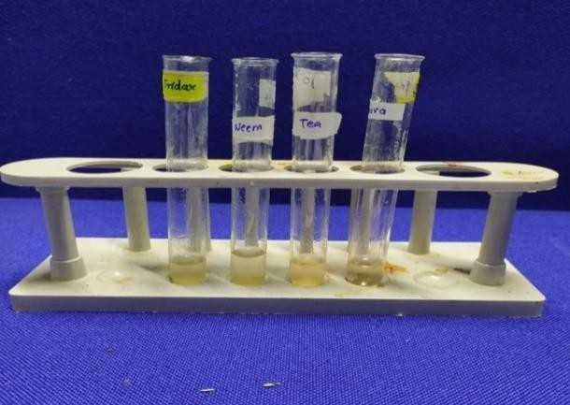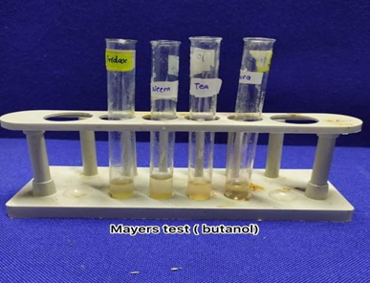
Figure 1(a) Figure 1(b)

Figure 1(a): Alkloid test of ethanolic extracts of Psidium gaujava leaves.
Figure 1(b): Alkloid test of butanolic extracts of Psidium gaujava leaves.

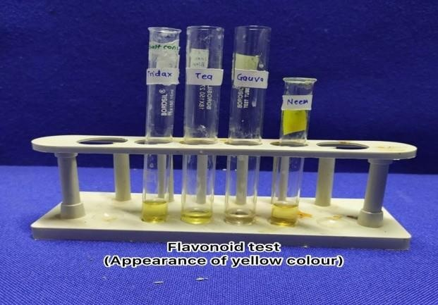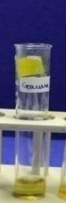
Figure 2(a) Figure 2(b)

Figure 2(a): Flavonoid test of ethanolic extracts of Psidium gaujava leaves.
Figure 2(b): Flavonoid test of butanolic extracts of Psidium gaujava leaves.

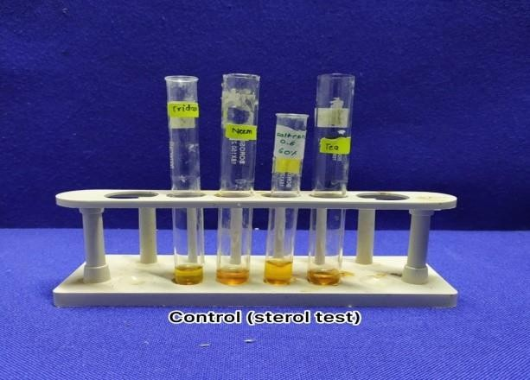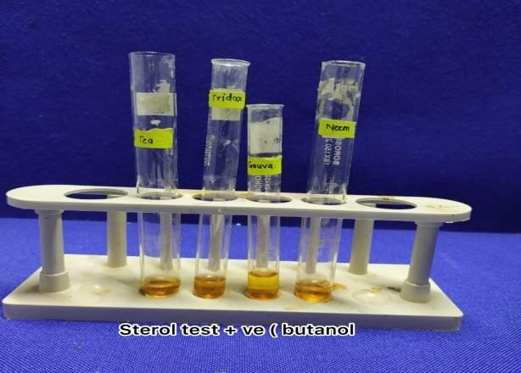
Figure 3(a) Figure 3(b)

Figure 3(a): Sterol test of ethanolic extracts of Psidium gaujava leaves.
Figure 3(b): Sterol test of butanolic extracts of Psidium gaujava leaves.

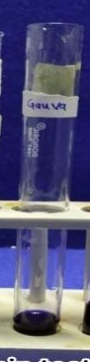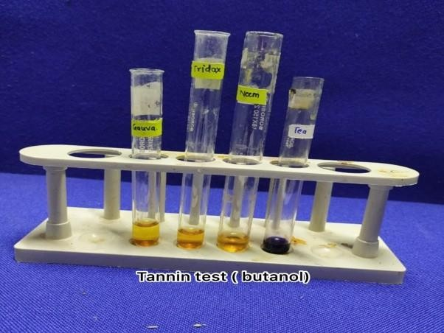
Figure 4a Figure 4b

Figure 4a: Tannin test of ethanolic extracts of Psidium gaujava leaves.
Figure 4b: Tannin test of butanolic extracts of Psidium gaujava leaves.

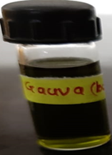

Figure 5: The ethanolic extract of Psidium guajava leaves obtained by the Soxhlet extraction method.

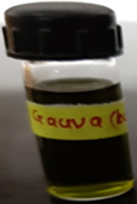

Figure 6: The butanolic extract of Psidium guajava leaves obtained by the Soxhlet extraction method.

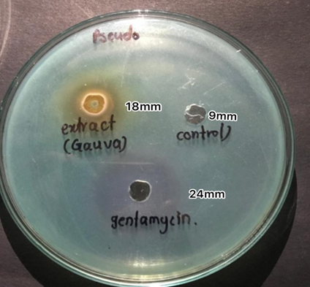

Figure 7: Antimicrobial activity of ethanolic extract of Psidium guajava leaves on Pseudomonas aeruginosa.

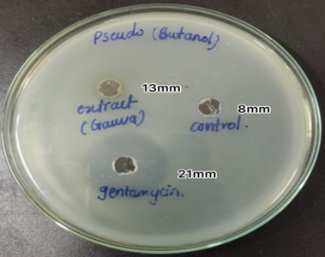

Figure 8: Antimicrobial activity of butanolic extract of Psidium gaujava leaves on Pseudomonas aeruginosa

